https://www.rheinzink.dk.rheinzink.typo-live.web-factory.de/index.php?id=2701:
Disse links fører ingen steder hen:
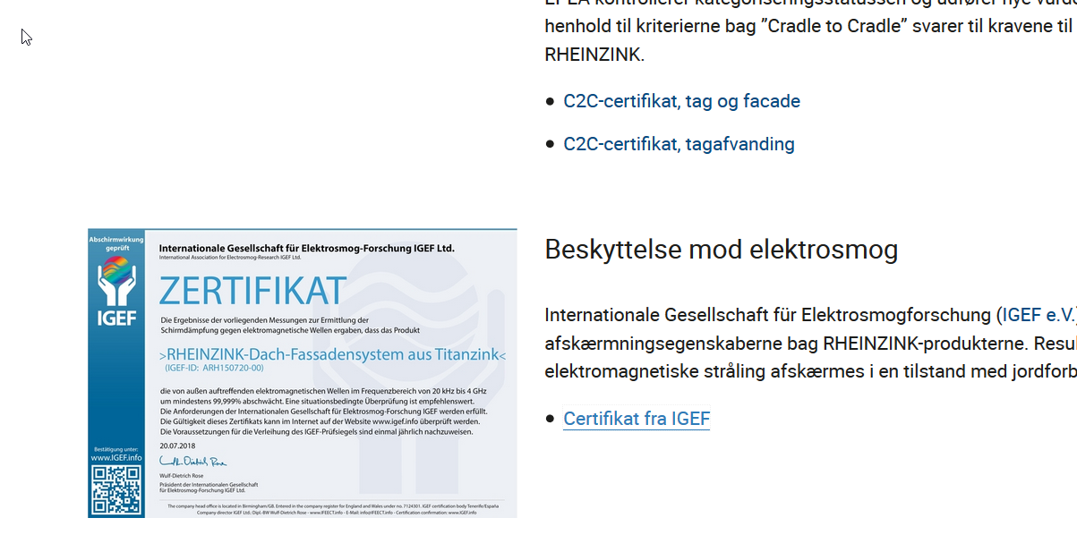

German stuff in the bottom?
https://www.rheinzink.dk.rheinzink.typo-live.web-factory.de/bygherrer/

